SW Architecture  <UHV> | 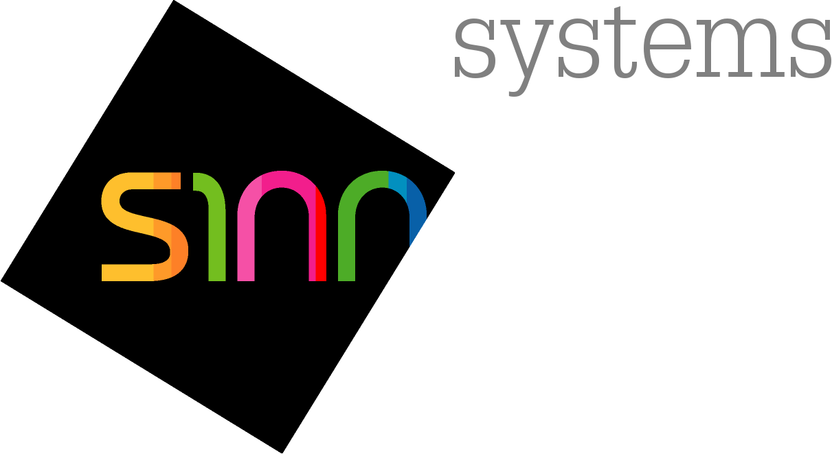

Anwendungsbereich / Scope

This document describes the Software architecture of project <UHV>

 | Verantwortlicher | Hüsnü Turkac
 | Tel | +49 (0) 711 90 12 19 86
 | Fax | +49 (0) 711 90 12 19 29
 | Email | Huesnue.Turkac@s1nn.de
 | Erstellt am | 2008-07-03
 | Aktualisiert am | 2009-09-07
 | Freigegeben von | HH
 | Freigegeben am | 2009-09-07
 | Version | 0.9
 | Status | Freigegeben

Historie

In der Änderungsdokumentation wird festgehalten, welche Änderungen des Dokuments in welcher Version stattgefunden haben. Ferner sind die bearbeitenden Personen für die jeweilige(n) Änderung(en) sowie das Änderungsdatum benannt.
Änderungshistorie / Revision Historie
Version | Änderungssgrund / Reason for Change | Erstellt | Bearbeiter | Freigabe
0.1 | Erstausgabe
0.2 | Überarbeitung nach Review vom 26.06.2008 (Turkac/Besemer) | 03.07.2008 | Besemer
0.3 | Überarbeitung nach Review vom 04.07.2008 (Turkac/Brust/v. Linde/Besemer) | 08.07.2008 | Besemer
0.4 | Tabelle für Use case ausgetauscht | 14.07.2008 | Besemer
0.5 | Email-Adresse und Modulliste hinzugefügt | 14.03.2009 | Turkac
0.6 | EEPROM-Layout added | 25.05.2009 | Turkac
0.7 | Variable Production Data Table added. and data location field added to the EEPROM Layout.  EEPROM data Coding Flag removed due to Coding Data can be used instead of. | 03.06.2009 | Turkac
0.8 | Update Feature MDI | 29.07.2009 | Turkac
0.9 | Rework after Review | 07.09.2009 | Turkac

Table of contents
1 Introduction 5
1.1 Purpose 5
1.2 Abbreviations and Glossary 5
2 Stakeholder and concerns 6
3 Traceability to SW requirements 6
4 View types 6
5 Views 9
5.1 Conceptual view 9
5.1.1 External System Interfaces 9
5.1.2 Internal System Interfaces 11
5.1.3 SW Block diagram of software subsystems in Host Block (TMS470) 13
5.1.4 Subsystem HMI 18
5.1.5 Use Case Diagrams of Feature Groups 18
5.2 Infrastructure view 58
5.3 Logical view 58
5.3.1 Static logical view 58
5.3.2 Dynamic logical view 62
5.3.3 Sequence diagrams 62
5.3.4 Inferfaces 63
5.3.5 Data handling 63
5.4 Process view 64
5.4.1 Tasks 64
5.4.2 Task Concept 65
5.4.3 Task activation 66
5.4.4 Performance Metrics 67
5.4.5 Assignment of modules 68
6 Fulfilment of non-functional requirements 70
6.1 Memory constraints 70
7 References 72
8 Tables and Figures 72
8.1 Tables 72
8.2 Figures 72

Introduction

Purpose
This document describes the Software architecture of the project UHV The software architecture is derived from the software requirements and is the base for the detailed design descriptions for the SW modules. It is a representation of the software system and its subsystems that is used as a medium for communicating software design information.
This document is written and maintained by the SW architect.
The UHV NAR interconnects a Bluetooth (BT) capable mobile device to the vehicle interface, to enable passengers or drivers remote controlling of mobile devices using the HMI controls. The UHV NAR enables to the user e.g. phone call, access to phonebook, or play a music file stored on the mobile device.
System stakeholders for the UHV NAR are given in figure 1.
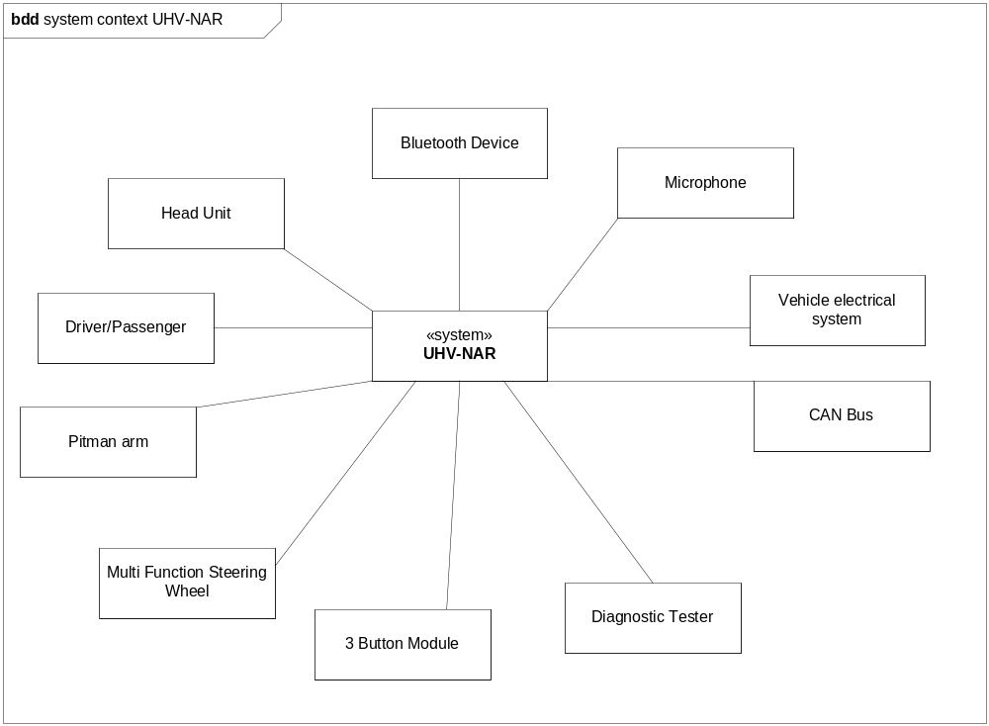
Figure 1 System stakeholders of UHV NAR

Abbreviations and Glossary
Abbreviation | Explanation
BAP | Bedien- und Anzeigenprotokoll
BT | Bluetooth
ERM | External Resource Manager
HMI | Human Machine Interface
HU | Head Unit
LSG | Logisches Steuergerät (Logical ECU)
LSS | Lenkstockschalter (Pitman Arm)
MFL | Multi-Funktions-Lenkrad (Multi-Function-Steering-Wheel)
NF | Nachfolger (Replacement)
NWM | Network Management
PTT | Push-To-Talk
SOW | Scope of Work
TTS | Text-To-Speech
UHV NAR | Universelle Handy Vorbereitung Nordamerikanischer Markt  Universal Mobile Preparation for North American Market
VW | Volkswagen
Table 1 Abbreviations and Glossary

Stakeholder and concerns
The information contained in this document is intended for
- the “SW Teilprojektleiter” to have an overview about the software, to identify risks and weaknesses of the SW and to use it for progress monitoring
- the “SW Anforderungsanalytiker” to verify that the software requirements can be realized by the chosen SW architecture
- the SW Designer to specify the SW modules, implement them, integrate them and perform SW integration tests
- the “SW Tester” to specify the test cases and execute the test cases

Traceability to SW requirements
Traceability between SW requirements and SW architecture is maintained by the traceability matrix in SWRS.
Traceability between subsystems, and modules are given in chapter 5.1.3.

View types
Describing the Software Architecture requires different views. The following table lists the standard view types that should be used to describe the different views on the software. If necessary, this list can be extended. It is not necessary to describe all of these views if the information is already contained in the system architectural design document (in this case reference to the appropriate chapter should be made).
View type | Explanation
Conceptual view type | Describes the system and its main functions using the vocabulary of the application domain. It shows an overview of the system and helps in understanding the other views. Usually it contains:  - The main functions of the system (corresponds to the “Logical view” of the system architecture)  - Conceptual building blocks of the system architecture (corresponds to the “Technical view” of the system architecture  - Interfaces and interconnections (including protocols) (corresponds to the “Interface view” of the system architecture  - (If applicable) independent of chosen Hardware or Software components (to enable trade-off analysis)  - Boundaries of the system including interfaces (e.g. sensors, actuators, other ECUs, user interface)
Infrastructure view type | Describes the Hardware of the system including  - The deployment and run-time environment (e.g. micro, memory, networks, communication interfaces)  - Performance characteristics and parameters (e.g. CPU, memory size, bandwidths)  This view may correspond to the “Technical view” of the system architecture.
Logical view type | Describes the SW functions and the SW building blocks (e.g. SW modules) including  - Static and dynamic dependencies  Separate views for the static aspects and the dynamic aspects should be used.  Static aspects describe  - The SW modules and their responsibilities (e.g. functions to be implemented)  - Dependencies between the SW modules (e.g. layered model)  - Change scenarios (e.g. replacement of a network interface or a hardware module)  Dynamic aspects describe the typical interactions of the SW modules using use cases including  - Start and stop of the system / software  - Diagnosis  - Typical scenarios of usage (e.g. complete signal flow)  - Error scenarios (e.g. out-of-range values)  - Safety-relevant scenarios
Process view type | Describes  - All relevant processes, threads and tasks  - Parallel and concurrent control flows including interrupt scheme (e.g. priority, pre-emption)  - Communication and synchronization between them
Component view type | Describes  - All executable SW components of the system (e.g. libraries, executables, hex-files)  - Build dependencies between them  - Documenting the origin of each component (e.g. library versions, reusable modules, standard software versions)
Partitioning view type | Describes  - The assignment (deployment) of SW components (from the component view) to HW components (from the infrastructure view)  - Which data is stored in which memory (e.g. volatile, non-volatile)
Table 1: Software Architectural View types

Views

Conceptual view
The system architecture is described in document System Architektur UHV - 1_0 draft.doc

External System Interfaces
Mute
Audio Right
Audio Left
CAN
Kl. 31
Microphone
Bluetooth
UHV
Cradle
3 Button Module
Figure 2 UHV and its interfaces
The UHV is a ECU, which interconnects a BT-capable mobile phone or player with a Head Unit or a Cluster Instrument. A Head Unit or Cluster Instrument can use the UHV NAR to control the BT capable mobile phone or player.
System Interface | Counterpart | Description of interface | System Component
Microphone | Mic Input | An external microphone can be plugged in, which can be muted or demuted by the ECU | Mic Input
Kl. 31 | Power Supply Interface | This interface is connected directly to the power supply of the vehicles 12 V battery. | Power Supply
CAN | CAN Transceiver Interface | The ECU is connected via Low Speed CAN (100 kBaud) to the car network. Control signals and BAP messages are send via CAN | CAN Transceiver
3 Button Module | 3 Button Module Interface | This module consists of 3 buttons, which has variant dependent functionality:  1. Bluetooth visibility, Microphone Mute and Push-To-Talk or  2. SOS, Breakdown Call, and Push-To-Talk  Each button has a corresponding voltage level. | 3 Button Module
Cradle | Cradle Interface | A cradle is used to enable emergency call, breakdown call, and to charge the battery of the mobile phone. | Cradle
Mute | Mute Driver | Communication units without CAN mute can be muted or demuted by HW mute interface. | Mute Driver
Audio Right | Audio Output Right | The audio stream is output on right channel received via A2DP from the mobile phone. The audio stream can be controlled by the TMS470. | Audio Output
Audio Left | Audio Output Left | The audio stream is output on right channel received via A2DP from the mobile phone. The audio stream can be controlled by the TMS470. | Audio Output
Bluetooth | Bluetooth Antenna | Bluetooth signals can be received and transmitted by this interface. HFP and/or AVRCP capable Bluetooth dev ices can be connected. | CK5050+ Module

Internal System Interfaces
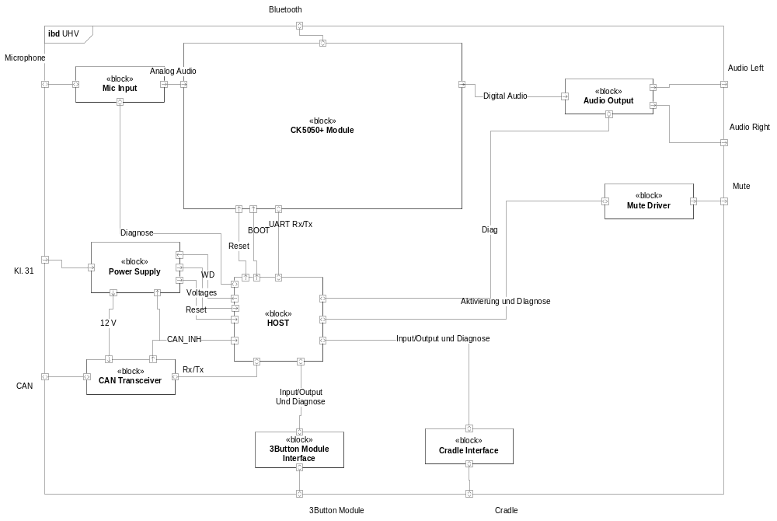

System Interface | Counterpart | Description of interface | Subsystem
Mic Diag | AD15 | Diagnosis interface of microphone | HAL
Power Supply | WD | Resets the power of the ECU | SYSTEM
ResetLine CK5050+ | Reset | Enables reset of CK5050+, when CK5050+ hangs or after reboot of TMS470 | GW
Power Supplay | Voltage | Voltage level for Diagnosis | SYSTEM
Power Supply | Reset | Reset indication line | GW
3BM | Input/Output/Diagnosis | Controlling the 3BM LED illumination  Processing of button states  Diagnosis of short circuit, break,and status | HAL, LL
Cradle | Input/Output/Diagnosis | Processing of button states  Diagnosis of short circuit, break,and status  Power on/off | HAL
Mute Driver | Aktivierung und Diagnose | Enables HW mute and diagnosis. | HAL
Audio Output | Diag | Diagnosis of audio out for short circuit. | DIAG
CK5050+ | UART Rx/Tx | Communication line via UART in both directions TMS470 and CK5050+. | GW
CK5050+ | BOOT | Set CK5050+ to Boot Mode. | GW
CAN Transceiver | CAN_INH | CAN inhibit line. | CAN
CAN Transceiver | Rx/Tx | CAN communication line | CAN
Table 2 System interfaces

SW Block diagram of software subsystems in Host Block (TMS470)

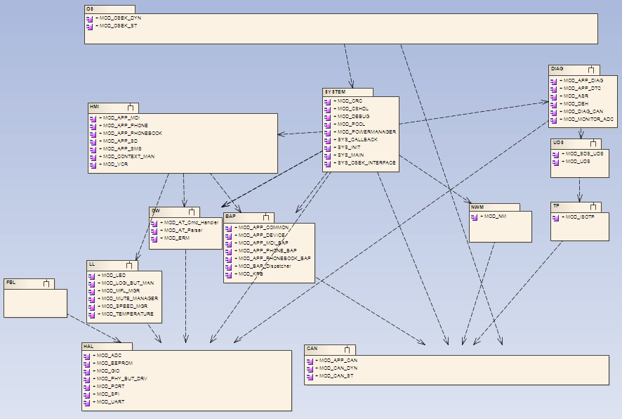

Figure 3 Block diagram of software subsystems
The Host SW consists of several SW subsystems, which are defined as high level SW components. Each Subsystem consists of one or several SW modules.
Subsystem | Description of interface | Modules
OS | This subsystem includes the Operating System OSEK with static and generated files | MOD_OSEK_DYN  MOD_OSEK_ST
SYSTEM | It comprises the ECU state machine (Central State Handler) and power management (POW) and system services (WD) | MOD_OSEK_INTERFACE  SYS_MAIN  SYS_INIT  SYS_CALLBACK  MOD_POWERMANAGER  MOD_POOL  MOD_DEBUG  MOD_CHSDL  MOD_CRC
CAN | This subsystem provides the CAN interface to the applications. It consists of the CAN driver, generated files by CANGen tool, and the application interface. | MOD_APP_CAN  MOD_CAN_DYN  MOD_CAN_ST
HAL | - The Hardware Abstraction Layer provides interfaces to the  - IO drivers like UART, EEPROM, and SPI  - processors ports GIO and PORT peripherals 3BM, Cradle, and Temperature Sensor, HW-Mute | .MOD_ADC  MOD_EEPROM  MOD_GIO  MOD_PHY_BUT_DRV  MOD_PORT  MOD_SPI  MOD_UART
HMI | The Human Machine Interface consists of applications Phone, Phonebook, SMS, Voice, Recognition, Media Player and Secondary Display. | MOD_APP_MDI  MOD_APP_PHONE  MOD_APP_PHONEBOOK  MOD_APP_SD  MOD_APP_SMS  MOD_CONTEXT_MAN  MOD_VCR
BAP | BAP-Protocol-Stack and interface to applications. | MOD_APP_MDI_BAP  MOD_APP_COMMON  MOD_APP_DEVICE  MOD_APP_PHONE_BAP  MOD_APP_PHONEBOOK_BAP  MOD_BAP_Dispatcher  MOD_KPB
GW | Maps functions to AT commands and parses response from CK5050+. Further it controls the state of CK5050+ like start-up and shutdown. | MOD_AT_Cmd_Handler  MOD_AT_Parser  MOD_ERM
NWM | The Network Management adapts the ECU to the VW based network. | MOD_NM
TP | The Transport Protocol Layer consists of the ISOTP to enable communication of diagnostic services. | MOD_ISOTP
DIAG | The Diagnostic Application Layer consists of Diagnostic Event Handler to enable storage of diagnostic trouble code, Diagnostic Application to interface SDS UDS to the applications, and monitoring of audio out, temperature, microphone in, 3BM, Cradle, and HW mute. | MOD_APP_DIAG  MOD_APP_DTC  MOD_ASR  MOD_DEH  MOD_DIAG_CAN  MOD_MONITOR_ADC
UDS | UDS service layer provides diagnostic services. | MOD_SDS_UDS  MOD_UDS
LL | The Logical Link and Application Layer abstract the behaviour of peripherals to logical instances. For instance, the Logical Button Manager handles PTT button independent where it come from. Thus, applications do not need to know who has triggered the PTT button the MFL, or 3BM, or something else. | MOD_LED  MOD_LOGI_BUT_MAN  MOD_MFL_MGR  MOD_MUTE_MANAGER  MOD_SPEED_MGR  MOD_TEMPERATURE
FBL | The Flash Bootloader enables updating of the ECU SW via CAN. | FBL_DATA

The subsystems communicate with well-defined interfaces. Those are listed below:
Subsystem interface | Subsystem | Called By Subsystem | Description of interface
SYS_OSEK_INTERFACE | SYSTEM | OS | Operating system functions can be used to define, and start/stop tasks to let schedule it by the OS. Alarms can be used to be notified, when a specified amount of time is elapsed.
SYS_CALLBACK | SYSTEM | OS | The operating system can call system functions, when an interrupt is released by CAN, Network Management or Alarms.
BAP TASK INTERFACE | BAP | OS | The subsystem OS calls the BAP-stack cyclically by using this interface.
BAP REQUEST | BAP | HMI | Applications can used this interface to deliver the response or any status change to the BAP based applications.
BAP INDICATION | HMI | BAP | This interface is for bidirectional communication of applications Media Player, Phone, Phonebook, SMS, Voice Recognition, and Secondary Display with ECUs like Headunit and Cluster Instrument.
EVENT HANDLER | HMI | LL | The Logical Layer notifies applications, when any button is pressed, e.g. 3 Button Module, MFL, or Cradle buttons.
EVENT HANDLER | HMI | OS | The subsystem calls event handler interface cyclically to dispatch received events.
AT INTERFACE | GW | HMI | Applications can control the CK5050+ by this interface or it can receive unsolicited events.
GW TASK INTERFACE | GW | SYSTEM | It is used by the subsystem SYSTEM to be called cyclically in order to process the AT commands.
NWM INTERFACE | NWM | SYSTEM | The subsystem SYSTEM calls cyclically the NM-Task. Further NWM-specific interrupts can be processed by this interface.
CAN INTERFACE | CAN | NWM, TP, BAP, SYSTEM,OS | Clients NWM, TP, and BAP use this interface to send message via CAN to other ECUs or to the VAS-Tester. The SYSTEM invokes cyclic Tasks. When a CAN message is received by the controller it causes a OSEK interrupt.
TP INTERFACE | TP | UDS | The diagnostic service layer uses this interface to send diagnostic service data. The data is assembled to data packages. It is reassembled by the VAS-Tester.
UDS INTERFACE | UDS | DIAG | Diagnostic application use this interface to serving requested diagnostic services.
DIAG TASK INTERFACE | DIAG | OS | Diagnostic task for monitoring of system components and interfaces is called cyclically by the OSEK task.
HAL INTERFACE | HAL | LL, GW, SYSTEM, DIAG, FBL | This interface provides access to peripherals like EEPROM, ADC, GIO, PORT, Physical Devices, SPI and the UART.
LOGICAL DEVICE INTERFACE | LL | HMI | This interface provides a general access from logical point of view. It can also notify, when any event occurs like button pressed.

Subsystem HMI

Use Case Diagrams of Feature Groups

Media Functionality
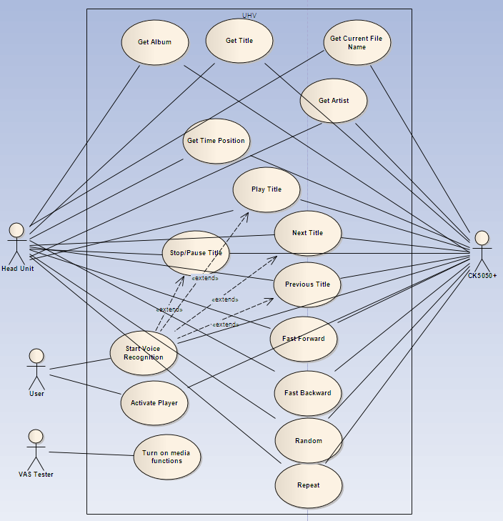
Actor | Description of actor
Head Unit | Head Unit can request track information and display it on its screen. It can control media functions on Host.
Diagnose Tester | It enables/disables media functionality via CAN.
User | The User can start voice recognition session by pressing the PTT button on MFL or 3BM. It can control media functions by voice recognition.
CK5050+ | This subsystem delivers the track information and provides interface to control media functions on phone device via AVCRP.

Use cases are derived from SWRS. The tracebility matrix between use cases and SWRS are given below:
USE CASE ID | SEQUENCE DIAGRAM ID | SWRS ID
UC_UHV_MDI_0000 | SD_UHV_MDI_0000 | SWRS_UHV_HMI_0005
UC_UHV_MDI_0001 | SD_UHV_MDI_0001 | SWRS_UHV_BAP_0022
UC_UHV_MDI_0002 | SD_UHV_MDI_0002 | SWRS_UHV_BAP_0022
UC_UHV_MDI_0003 | SD_UHV_MDI_0003 | SWRS_UHV_BAP_0022
UC_UHV_MDI_0005 | SD_UHV_MDI_0005 | SWRS_UHV_BAP_0021
UC_UHV_MDI_0006 | SD_UHV_MDI_0006 | SWRS_UHV_BAP_0014
UC_UHV_MDI_0007 | SD_UHV_MDI_0007 | SWRS_UHV_BAP_0014
UC_UHV_MDI_0008 | SD_UHV_MDI_0008 | SWRS_UHV_HMI_0001  SWRS_UHV_HMI_0006  SWRS_UHV_HMI_0007  SWRS_UHV_HMI_0008  SWRS_UHV_HMI_0009  SWRS_UHV_HMI_0011  SWRS_UHV_BAP_0011
UC_UHV_MDI_0009 | SD_UHV_MDI_0009 | SWRS_UHV_HMI_0001  SWRS_UHV_HMI_0006  SWRS_UHV_HMI_0007  SWRS_UHV_HMI_0008  SWRS_UHV_HMI_0009  SWRS_UHV_HMI_0011  SWRS_UHV_BAP_0011
UC_UHV_MDI_0010 | SD_UHV_MDI_0010 | SWRS_UHV_HMI_0001  SWRS_UHV_HMI_0006  SWRS_UHV_HMI_0007  SWRS_UHV_HMI_0008  SWRS_UHV_HMI_0009  SWRS_UHV_HMI_0011  SWRS_UHV_BAP_0011  SWRS_UHV_BAP_0016
UC_UHV_MDI_0011 | SD_UHV_MDI_0011 | SWRS_UHV_HMI_0001  SWRS_UHV_HMI_0006  SWRS_UHV_HMI_0007  SWRS_UHV_HMI_0008  SWRS_UHV_HMI_0009  SWRS_UHV_HMI_0011  SWRS_UHV_BAP_0011  SWRS_UHV_BAP_0017
UC_UHV_MDI_0012 | SD_UHV_MDI_0012 | SWRS_UHV_BAP_0011
UC_UHV_MDI_0013 | SD_UHV_MDI_0013 | SWRS_UHV_BAP_0011
UC_UHV_MDI_0014 | SD_UHV_MDI_0014 | SWRS_UHV_BAP_0018
UC_UHV_MDI_0015 | SD_UHV_MDI_0015 | SWRS_UHV_BAP_0020
UC_UHV_MDI_0016 | SD_UHV_MDI_0016 | SWRS_UHV_HMI_0002  SWRS_UHV_HMI_0003  SWRS_UHV_HMI_0008
UC_UHV_MDI_0017 | SD_UHV_MDI_0017 | SWRS_UHV_HMI_0002  SWRS_UHV_HMI_0010

Use Case Description:
Use Case ID: | UC_UHV_MDI_0000
Name of use case: | Activate Player
Goal: | Activation of the selected Player.
Rationale:
Pre-condition: | UHV is active.  BT device is ready.  BT-Media context is supported by HU.  Media capable BT device is connected.  Media function is turned on by diagnosis.
Normal flow: | Activate selected Player.
Post conditions success: | Selected Player is connected and displayed on HU or CI
Post conditions failure: | Device is not activated.
Alternative flow: | None

Sequence Diagram Activate Selected Player: SD_UHV_MDI_0000
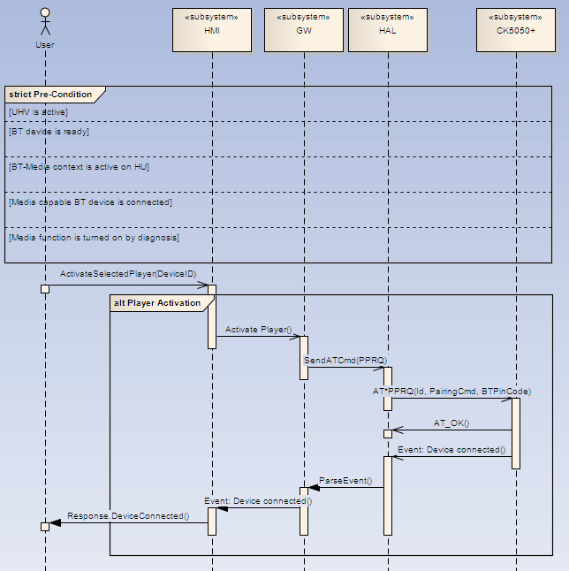

Use Case ID: | UC_UHV_MDI_0001
Name of use case: | Get Album
Goal: | Display album information.
Rationale:
Pre-condition: | UHV is active.  BT device is ready.  BT-Media context is active on HU.  Media capable BT device is connected.  Media function is turned on by diagnosis.
Normal flow: | Retrieve the album information by BAP protocol.
Post conditions success: | The current album information is displayed on HU.
Post conditions failure: | No album information is displayed on HU.
Alternative flow: | None

Sequence Diagram GetAlbum SD_UHV_MDI_0001:
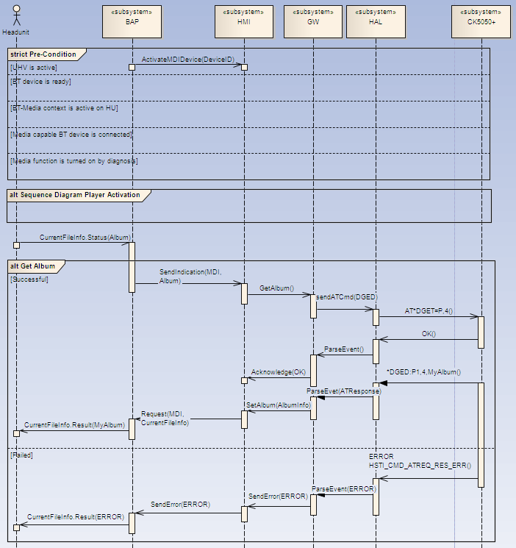

Use Case ID: | UC_UHV_MDI_0002
Name of use case: | Get Artist
Goal: | Display artist information.
Rationale:
Pre-condition: | UHV is active.  BT device is ready.  BT-Media context is active on HU.  Media capable BT device is connected.  Media function is turned on by diagnosis.
Normal flow: | Retrieve the artist information by BAP protocol.
Post conditions success: | The current artist information is displayed on HU.
Post conditions failure: | No artist information is displayed on HU.
Alternative flow: | None

Sequence Diagram GetArtist: SD_UHV_MDI_0002:
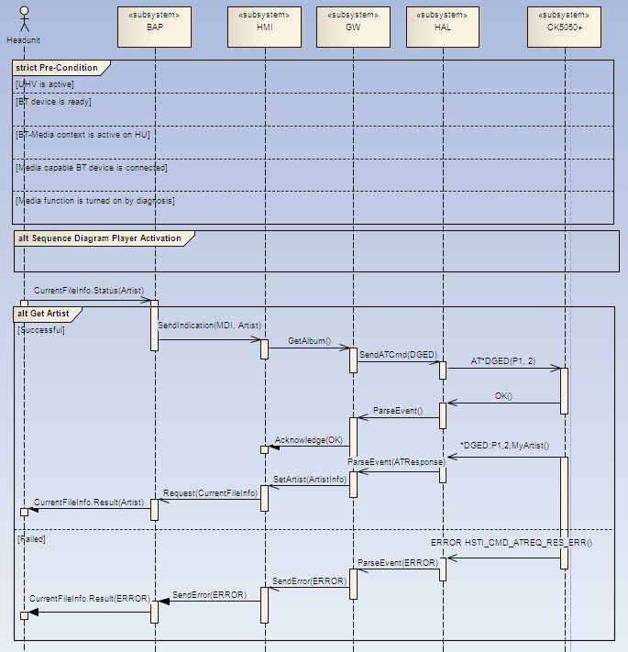

Use Case ID: | UC_UHV_MDI_0003
Name of use case: | Get Title
Goal: | Display title information.
Rationale:
Pre-condition: | UHV is active.  BT device is ready.  BT-Media context is active on HU.  Media capable BT device is connected.  Media function is turned on by diagnosis.
Normal flow: | Retrieve the title information by BAP protocol.
Post conditions success: | The current title information is displayed on HU.
Post conditions failure: | No title information is displayed on HU.
Alternative flow: | None

Sequence Diagram GetTitle: SD_UHV_MDI_0003
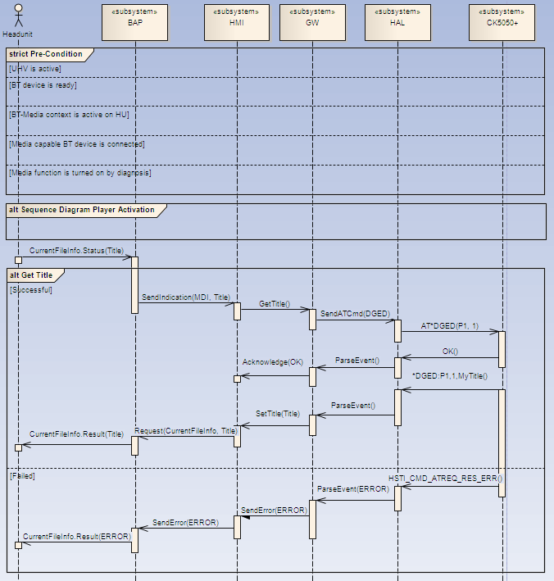

Use Case ID: | UC_UHV_MDI_0005
Name of use case: | Get Current File Name
Goal: | Display Current File Name information.
Rationale:
Pre-condition: | UHV is active.  BT device is ready.  BT-Media context is active on HU.  Media capable BT device is connected.  Media function is turned on by diagnosis.
Normal flow: | Retrieve the Current File Name information by BAP protocol.
Post conditions success: | The current Current File Name information is displayed on HU.
Post conditions failure: | No Current File Name information is displayed on HU.
Alternative flow: | None

Sequence Diagram GetCurrentFileName: SD_UHV_MDI_0005
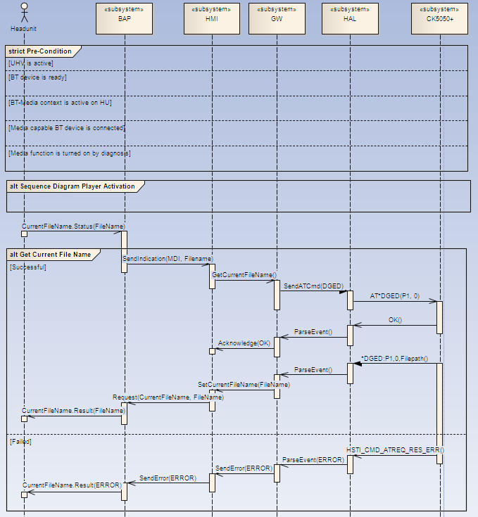

Use Case ID: | UC_UHV_MDI_0006
Name of use case: | Get Time Position
Goal: | Display Current Time Position.
Rationale:
Pre-condition: | UHV is active.  BT device is ready.  BT-Media context is active on HU.  Media capable BT device is connected.  Media device supports time position information.  Media function is turned on by diagnosis.
Normal flow: | Play title.  Retrieve the current time position information by BAP protocol.
Post conditions success: | The current current time position information is displayed on HU.
Post conditions failure: | No current time position is displayed on HU.
Alternative flow: | Skip Forward/Skip Backward  Retrieve the Current Time Information by BAP protocol

Sequence Diagram Get Time Position: SD_UHV_MDI_0006
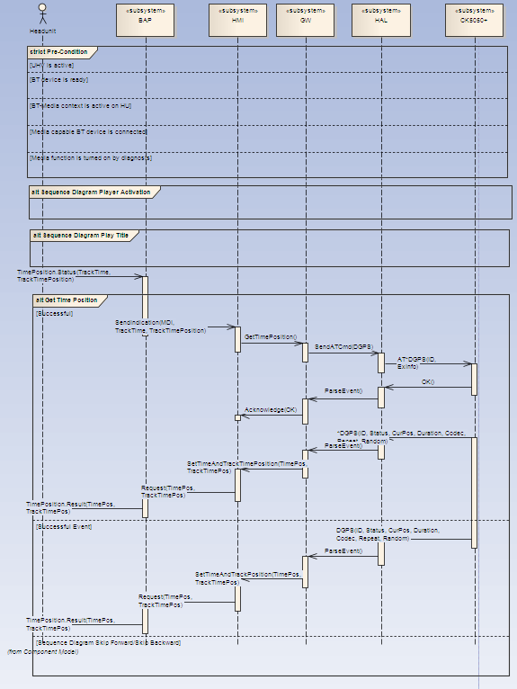

Use Case ID: | UC_UHV_MDI_0007
Name of use case: | Get Time Position
Goal: | Display Current Time Position.
Rationale:
Pre-condition: | UHV is active.  BT device is ready.  BT-Media context is active on HU.  Media capable BT device is connected.  Media device does not supports time position information.  Media function is turned on by diagnosis.
Normal flow: | Play title.  Retrieve the current time position information by BAP protocol.
Post conditions success: | The current current time position information is not displayed on HU.
Post conditions failure: | none
Alternative flow: | Skip Forward/Skip Backward  Retrieve the Current Time Information by BAP protocol

Sequence Diagram Get Time Position: SD_UHV_MDI_0007

Use Case ID: | UC_UHV_MDI_0008
Name of use case: | Play Title
Goal: | Play selected music title.
Rationale:
Pre-condition: | UHV is active.  BT device is ready.  BT-Media context is active on HU.  Media capable BT device is connected.  Media device supports at least AVRCP 1.2.  UHV is not muted and mute reason audio media is send to HU.  Media function is turned on by diagnosis.
Normal flow: | HU sends play request via BAP.  Send play request to BT-module.
Post conditions success: | The selected music title is played and audible.
Post conditions failure: | The music title is not audible.
Alternative flow: | Voice recognition requests playing music title.  Send play request to BT-module.

Sequence Diagram Play Title: SD_UHV_MDI_0008
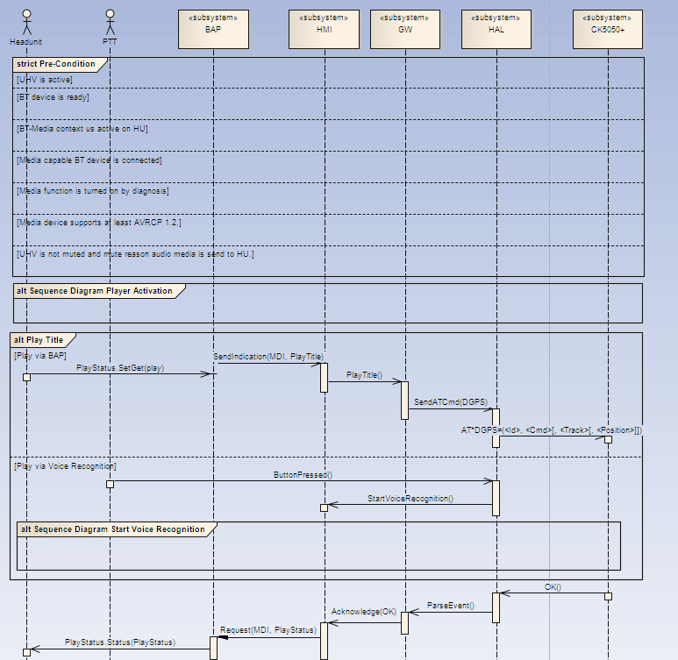

Use Case ID: | UC_UHV_MDI_0009
Name of use case: | Stop/Pause Title
Goal: | Stop/Pause selected music title.
Rationale:
Pre-condition: | UHV is active.  BT device is ready.  BT-Media context is active on HU.  Media capable BT device is connected.  Media device supports at least AVRCP 1.2.  UHV is not muted and mute reason audio media is send to HU.  Media function is turned on by diagnosis.
Normal flow: | HU sends stop/pause request via BAP.  Send stop/pause request to BT-module.
Post conditions success: | The selected music title is stopped/paused and is not audible.
Post conditions failure: | The music title is audible.  UHV sends unmute reason audio media to HU.
Alternative flow: | Voice recognition requests stop/pause music title.  Send stop/pause request to BT-module.

Sequence Diagram Stop/Pause Title: SD_UHV_MDI_0009
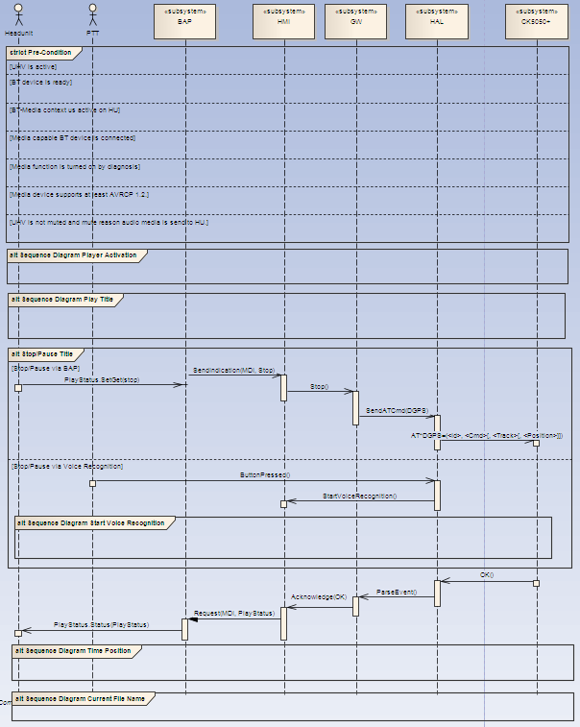

Use Case ID: | UC_UHV_MDI_0010
Name of use case: | Next Title
Goal: | Play next music title.
Rationale:
Pre-condition: | UHV is active.  BT device is ready.  BT-Media context is active on HU.  Media capable BT device is connected.  Media device supports at least AVRCP 1.2.  UHV is not muted and mute reason audio media is send to HU.  Media function is turned on by diagnosis.
Normal flow: | HU sends Forward request via BAP.  Send Forward request to BT-module.
Post conditions success: | The next music title is played and is audible.
Post conditions failure: | The music title is not audible.  The music is stopped.
Alternative flow: | Voice recognition requests Forward music title.  Send Forward request to BT-module.

Sequence Diagram Next Title: SD_UHV_MDI_0010:
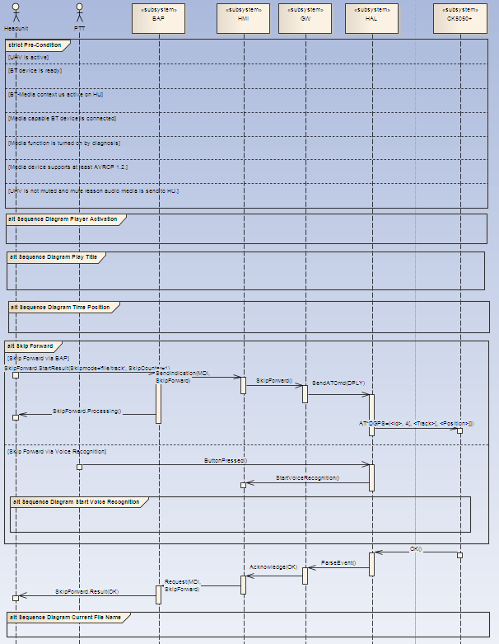

Use Case ID: | UC_UHV_MDI_0011
Name of use case: | Previous Title
Goal: | Play previous music title.
Rationale:
Pre-condition: | UHV is active.  BT device is ready.  BT-Media context is active on HU.  Media capable BT device is connected.  Media device supports at least AVRCP 1.2.  UHV is not muted and mute reason audio media is send to HU.  Media function is turned on by diagnosis.
Normal flow: | HU sends Backward request via BAP.  Send Backward request to BT-module.
Post conditions success: | The previous music title is played and is audible.
Post conditions failure: | The music title is not audible.  The music is stopped.
Alternative flow: | Voice recognition requests Backward music title.  Send Backward request to BT-module.

Sequence Diagram Previous Title: SD_UHV_MDI_0011:
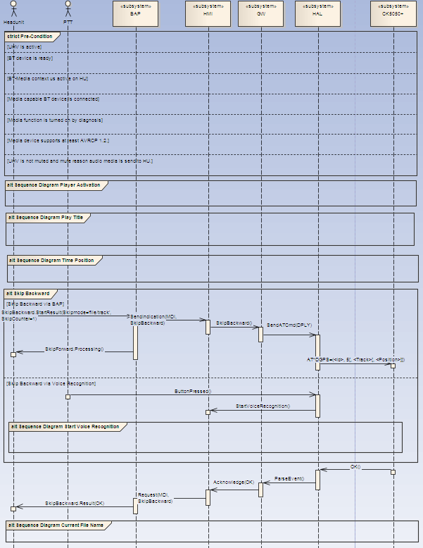

Use Case ID: | UC_UHV_MDI_0012
Name of use case: | Fast Forward Title
Goal: | Fast forward music title.
Rationale:
Pre-condition: | UHV is active.  BT device is ready.  BT-Media context is active on HU.  Media capable BT device is connected.  Media device supports at least AVRCP 1.2.  Time position is supported by the BT media device.  UHV is not muted and mute reason audio media is send to HU.  Media function is turned on by diagnosis.
Normal flow: | HU sends Fast Forward request via BAP.  Send Fast Forward request to BT-module.  Get Time Position.
Post conditions success: | The music title is fast forwarded.  Time position is increasing.
Post conditions failure: | The music title is not fast forwarded.  The music is stopped.  The music title is audible.
Alternative flow: | None

Sequence Diagram Fast Forward Title: SD_UHV_MDI_0012:
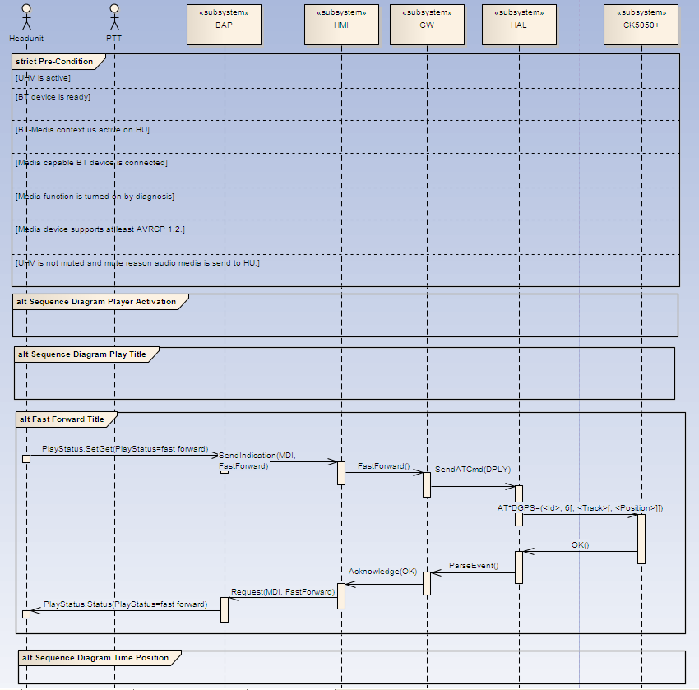

Use Case ID: | UC_UHV_MDI_0013
Name of use case: | Fast Backward Title
Goal: | Fast backward music title.
Rationale:
Pre-condition: | UHV is active.  BT device is ready.  BT-Media context is active on HU.  Media capable BT device is connected.  Media device supports at least AVRCP 1.2.  Time position is supported by the BT media device.  UHV is not muted and mute reason audio media is send to HU.  Media function is turned on by diagnosis.
Normal flow: | HU sends Fast Backward request via BAP.  Send Fast Backward request to BT-module.  Get Time Position.
Post conditions success: | The music title is fast back warded.  Time position is increasing.
Post conditions failure: | The music title is not fast back warded.  The music is stopped.  The music title is audible.
Alternative flow: | None

Sequence Diagram Fast Forward Title: SD_UHV_MDI_0013:
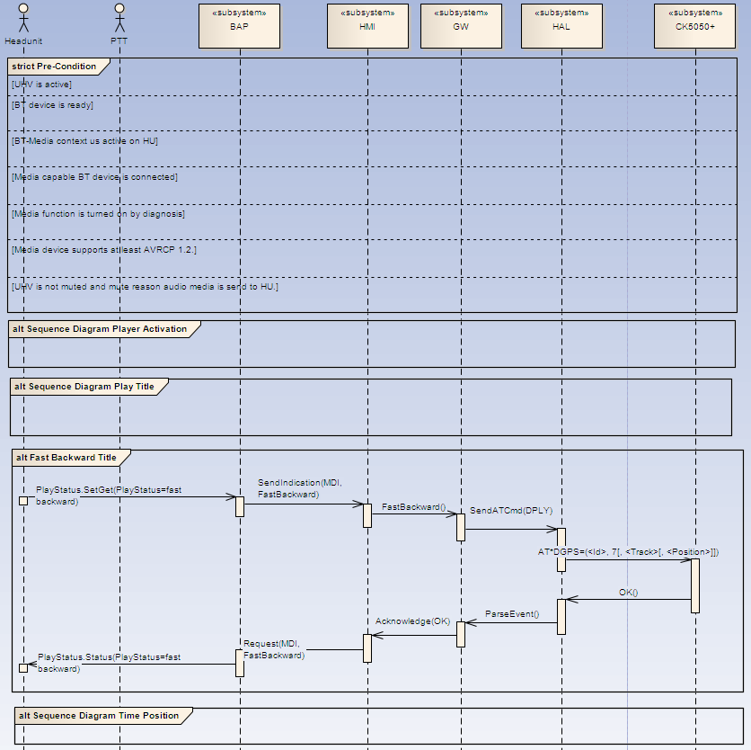

Use Case ID: | UC_UHV_MDI_0014
Name of use case: | Random
Goal: | Activate random mode.
Rationale:
Pre-condition: | UHV is active.  BT device is ready.  BT-Media context is active on HU.  Media capable BT device is connected.  Media device supports at least AVRCP 1.2.  UHV is not muted and mute reason audio media is send to HU.  Media function is turned on by diagnosis.
Normal flow: | HU sends Random request via BAP.  Send Random request to BT-module.  Play music title.
Post conditions success: | The random mode is active. Music titles are played randomized.  Music title is audible.
Post conditions failure: | The mode is not set to random.  The music is stopped.  The music title is not audible.
Alternative flow: | None

Sequence Diagram Random: SD_UHV_MDI_0014:
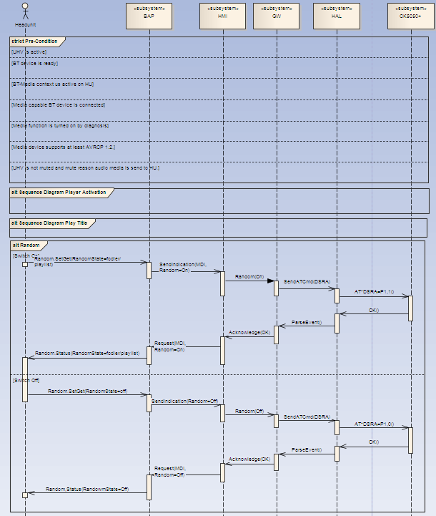

Use Case ID: | UC_UHV_MDI_0015
Name of use case: | Repeat
Goal: | Activate repeat mode.
Rationale:
Pre-condition: | UHV is active.  BT device is ready.  BT-Media context is active on HU.  Media capable BT device is connected.  Media device supports at least AVRCP 1.2.  UHV is not muted and mute reason audio media is send to HU.  Media function is turned on by diagnosis.
Normal flow: | HU sends Repeat request via BAP.  Send Repeat request to BT-module.  Play music title.
Post conditions success: | The repeat mode is active. Music title is repeated.  Music title is audible.
Post conditions failure: | The mode is not set to repeat.  The music is stopped.  The music title is not audible.
Alternative flow: | None

Sequence Diagram Repeat: SD_UHV_MDI_0015:
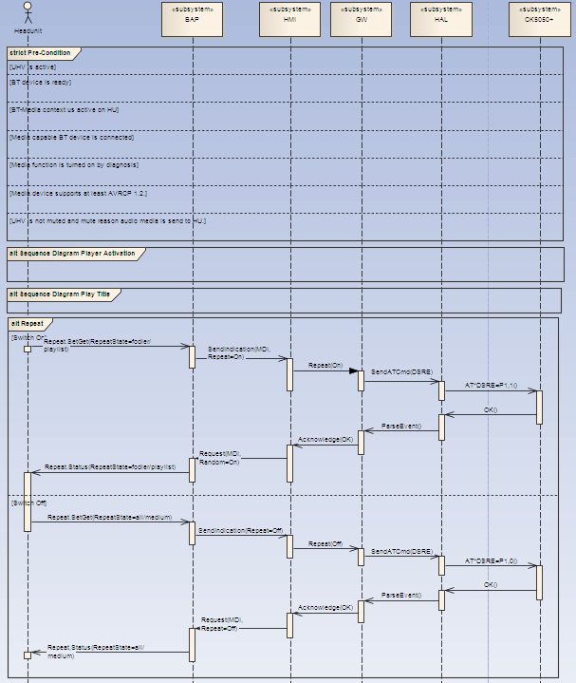

Use Case ID: | UC_UHV_MDI_0016
Name of use case: | Start Voice Recognition
Goal: | Start Speech Dialog System
Rationale:
Pre-condition: | UHV is active.  BT device is ready.  Media capable BT device is connected.  Media device supports at least AVRCP 1.2.  Media function is turned on by diagnosis.
Normal flow: | The user presses PTT button to activate the Speech Dialog System (SDS).  UHV starts the SDS on CK5050+.
Post conditions success: | SDS is active and ready.  SDS status is displayed on HMI.  SDS output is audible.
Post conditions failure: | SDS output is not audible.  SDS status is not displayed on HMI.
Alternative flow: | None

Sequence Diagram Start Voice Recognition: SD_UHV_MDI_0016:
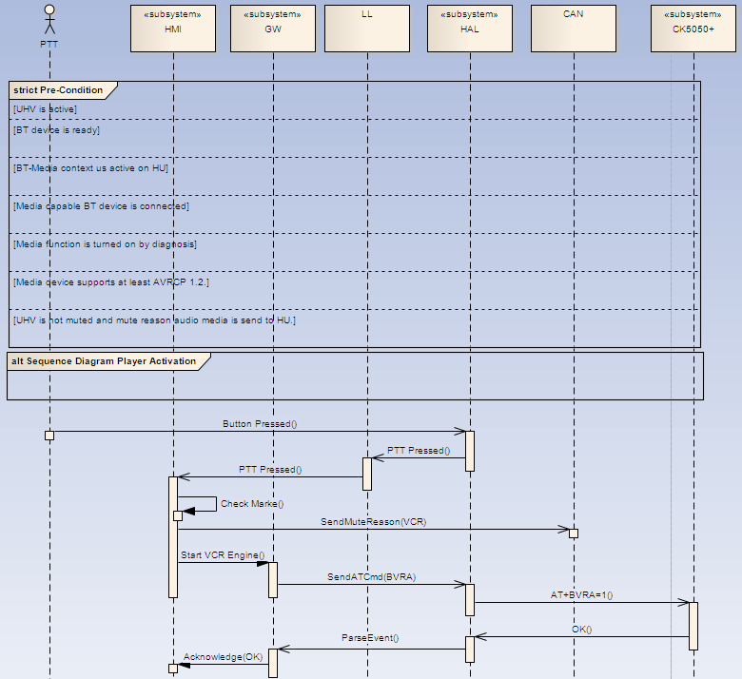

Use Case ID: | UC_UHV_MDI_0017
Name of use case: | Turn on/off media function
Goal: | Activate/Deactivate media functionality on UHV
Rationale:
Pre-condition: | UHV is active.  BT device is ready.  Media capable BT device is connected.  Media device supports at least AVRCP 1.2.  Media function is turned on by diagnosis.
Normal flow: | The VAS Tester sets coding media functionality to off.  Deactivate all media functionalities.
Post conditions success: | Coding value of media functionality is off.  SDS does not provide and output media functionality.
Post conditions failure: | Media functionality is coded.  SDS outputs availability of media functionality.
Alternative flow: | None

Sequence Diagram Turn on/off media function: SD_UHV_MDI_0017:
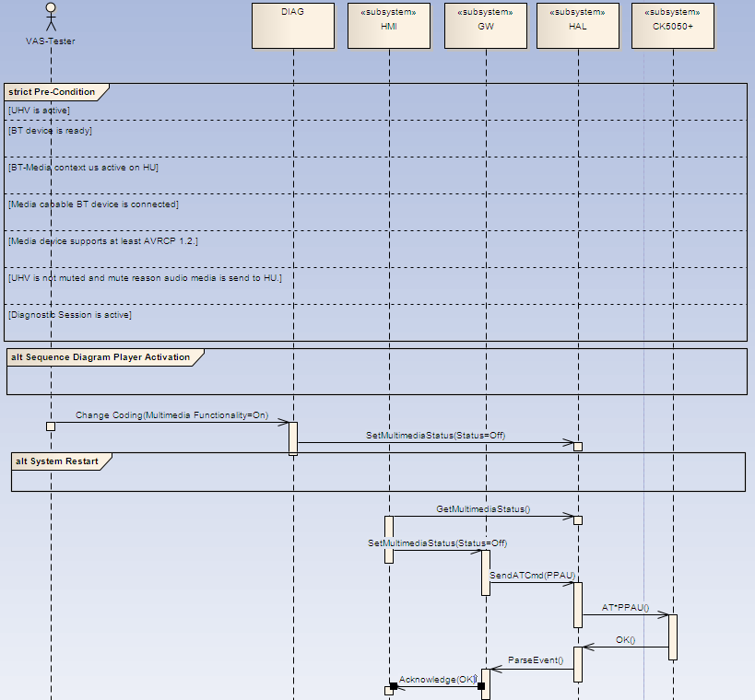

Telephone Functionality

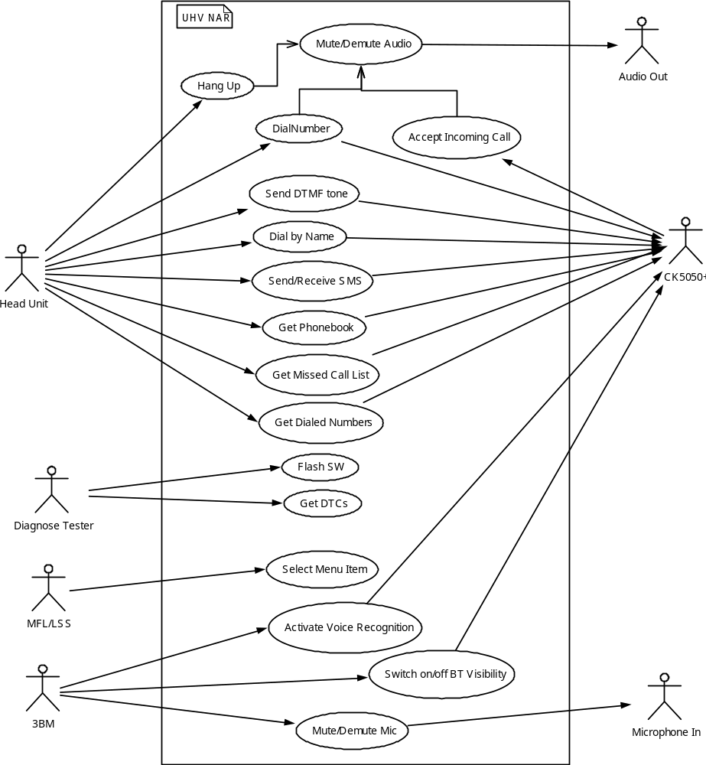

Figure 4 Use case diagram

Actor | Description of actor
Head Unit | Head Unit can display and control functions like telephone, phonebook, Mute/Demute etc. and communicates with UHV via BAP-Protocol via CAN.
Diagnose Tester | This actor can request data and services specific for diagnosis sessions.
MFL/LSS | Both MFL and LSS send different button/wheel status to the UHV via CAN in order to control the UHVs Telephone Context in Secondary Display.
3BM | This unit provides 3 Buttons, where the functionalities depends on the car: PTT, Bluetooth visibility, and MicroMute.
Audio Out | A audio stream or voice call can be directed to this unit.
Microphone In | An external microphone signal can be directed to this unit.
Cradle | The cradle provides to 2 buttons, antenna input, and power supply on/off line.
CK5050+ | This unit can accept AT command requests and can send unsolicited events to the system.
Table 3 Overview Actors

Name of use case: | Hang Up
Goal: | A call can be completed.
Rationale:
Pre-condition: | BT device is ready.  A call is active
Normal flow: | PTT on 3BM is pressed. The hangup request is send to the CK5050+.. Send demute request to HU.
Post conditions success: | Call is not active. Audio is demuted.
Post conditions failure: | Call is still active.
Alternative flow: | Hangup is triggered by the HU.

Name of use case: | Dial number
Goal: | A call is established.
Rationale:
Pre-condition: | BT device is ready.
Normal flow: | HU sends a request for dial number. The request is forwarded to the CK5050+. Send mute request to HU.
Post conditions success: | Call is active. Audio is muted
Post conditions failure: | Call is not active.
Alternative flow: | Hangup is triggered by the HU.

Name of use case: | Flash SW
Goal: | SW is updated on ECU
Rationale:
Pre-condition: | Cl. 15 on. Diagnose Tester is connected to the car/UHV. Basisvariante is correct.
Normal flow: | Select SW update on VAS Tester. Tester sends a update requests to UHV. The ECU verifies the received data and starts update process.
Post conditions success: | SW is updated and UHV is restarted.
Post conditions failure: | No reaction of UHV after flash process
Alternative flow: | none

Infrastructure view

Infrastructer is described in System Architecture.

Logical view

Static logical view

The SW consists of different SW layers as depicted in figure 4 software layers

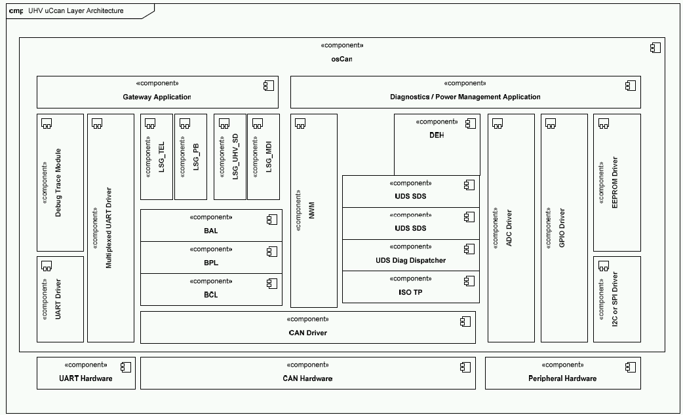
Figure 5 Software layers

Describe each software module including extend of the module and responsibilities of the module.
SW module name | Subsystem | Functions to be implemented by this module
FBL | FBL | Flash bootloader performes the transmission and update of the host and CK5050+ subsystems.
MOD_ADC | HAL | Reads analog to digital input of controller for  - Temperature measurement  - 3-Button-Modul out  - Cradle out  - Power supply voltage
MOD_APP_CAN | CAN | This modules manages CAN messages and provide interface for several CAN signals.
MOD_APP_COMMON | BAP | Common headers for this project are stored here.
MOD_APP_CSHDL | SYSTEM | Manages the system state machine depending of the Clamp status and CK5050+.
MOD_APP_DEVICE | HMI
MOD_APP_DIAG | DIAG | Provides interfaces to diagnostic specific data.
MOD_APP_DTC | DIAG | Provides common interface to store diagnostic trouble code
MOD_APP_MDI | HMI | Enables media device functionality on BT devices
MOD_APP_MDI_BAP | BAP | Interconnects media device features to car network via BAP
MOD_APP_PHONE | HMI | Enables phone functionality like dial number, conference call, etc.
MOD_APP_PHONE_BAP | BAP | Interconnects phone features to car network via BAP
MOD_APP_PHONEBOOK | HMI | Enables phonebook functionality like retrieving phonebook entry, add phonebook entry, dial from phonebook, etc.
MOD_APP_PHONEBOOK_BAP | BAP | Interconnects phonebook features to car network via BAP
MOD_APP_SD | HMI | Implements the telephone context for cluster instrument.
MOD_APP_SMS | HMI | Enables SMS functionality like receive/send SMS, send concatenated SMS, etc.
MOD_ASR | DIAG | Provides voice recognition performance metrics via CAN to an external processing Tool.
MOD_AT_Cmd_Handler | GW | Provides interface to CK5050+ and assemblies the AT commands.
MOD_AT_Parser | GW | Parses the responses and events send by the CK5050+ and forwards to the corresponding application.
MOD_BAP | BAP | Implements the BAP stack.
MOD_BAP_DISPATCHER | BAP | Dispatches the BAP requests to function calls. Therefore it invokes the corresponding application. It also maps the response of the application to a BAP response.
MOD_CAN_DYN | CAN | It comprises the generated CAN files based on CAN configuration.
MOD_CAN_ST | CAN | It comprises all configuration and required files therefore.
MOD_CONTEXT_MAN | HMI | The context manager processes any trigger (e.g. PTT-Button pressed) depending from the current active context (e.g. Voice Recognition or Telephone) and car type.
MOD_CRC | SYSTEM | It calculates the CRC checksum, when system starts up and compares the values with stored CRC checksum in EEPROM. In case of corrupt CRC a backup data is loaded.
MOD_CSHDL | SYSTEM | Controls the whole system state from power off to active mode.
MOD_DEBUG | SYSTEM | Provides debug interface to application in order to output information on UART2. This output can be logged by an external tool.
MOD_DEH | DIAG | Configures the error stiorage.
MOD_DIAG_CAN | DIAG | Provides interface to diagnostic services to retrieve diagnostic related data or perform actions.
MOD_EEPROM | HAL | EEPROM driver manages data to write and read to/from EEPROM.
MOD_ERM | GW | External Ressource Manager coordinates startup of CK5050+ and allocation of UART resources and CK5050+ specific services.
MOD_FBL_DATA | FBL | Comprices flash bootloader specific data.
MOD_GIO | HAL | Initializes GIO registers and provide access to it.
MOD_ISOTP | TP | The implementation and configuration of the ISOTP module.
MOD_KPB | BAP | Implementation of the KPB module.
MOD_LED | LL | Controls the LED illumination of the 3 Button Module.
MOD_LOGI_BUT_MAN | LL | Logical button Manager provides a general interface for button events. It forwards button request to the Context Manager.
MOD_MFL_MGR | LL | MFL Manager processes CAN messages send by the MFL ECU.
MOD_MONITOR_ADC | DIAG | This provides an interface for diagnosis services.
MOD_MUTE_MANAGER | LL | Sends Mute/Demute request to the HU depending from the context.
MOD_NM | NWM | Implementation of the Network Manangement.
MOD_OSEK_DYN | OS | Generated files for OSEK are located here.
MOD_OSEK_ST | OS | OSEK configuration and static files are located here.
MOD_PHY_BUT_DRV | HAL | Driver for 3 Button Module.
MOD_POOL | SYSTEM | Memory allocation management module.
MOD_PORT | HAL | Provides platform independent access to HW ports.
MOD_POWERMANAGER | SYSTEM | Startup and POW.
MOD_SDS_UDS | UDS | Provides interface for diagnostic services
MOD_SPEED_MGR | LL | Controls speed limitation for BT visibility.
MOD_SPI | HAL | Device driver for SPI interface.
MOD_SYS_INIT | SYSTEM | Performs the initialization of system at start up.
MOD_TEMPERATURE | LL | Monitors temperature level
MOD_UART | HAL | UART driver interfaces different modules for communication with debug interface and CK5050+.
MOD_UDS | UDS | UDS Layer of Standard SW delivered by VW.
MOD_VCR | HMI | Controls the SDS of CK5050+ and interacts with the HMI to display the SDS status information like “Voice recognition active”.
MOD_WD | SYSTEM | The watchdog module triggers cyclically the HW watchdog to keep SW alive. In case of hang up of the system it will perform a system reset.
SYS_CALLBACK | SYSTEM | Implements interrupt routines for CAN, ISR, and NWM.
SYS_MAIN | SYSTEM | Includes the main start-up routine with initialization of the different sections in RAM.
SYS_OSEK_INTERFACE | SYSTEM | Implements different Tasks which are invoked by the OSEK-Tasks.
Table 4 Software module descriptions

Dynamic logical view
Implemented later

Sequence diagrams
The start-up sequence of the UHV is given in following interaction diagram.

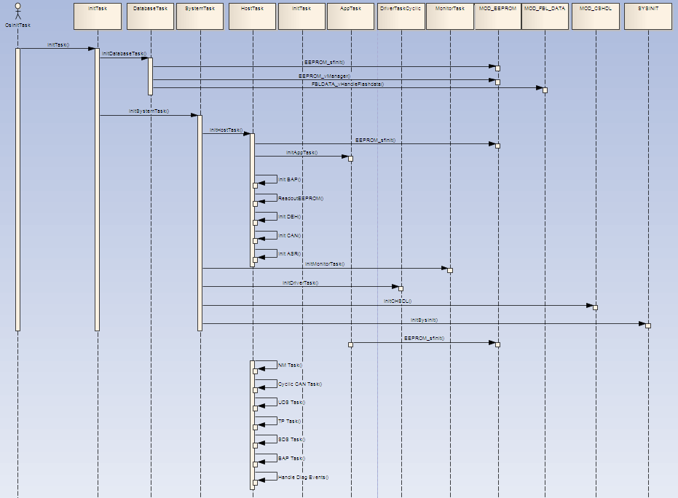
Figure 6 Dynamic logical view of the Q5 CAN Amp

Inferfaces
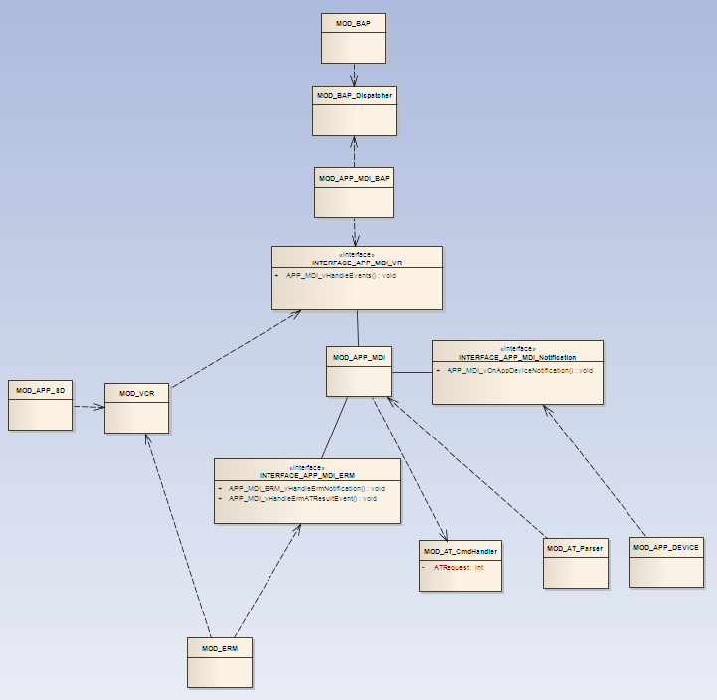

Figure 7 Interface example
Interface name | Description | Functions
INTERFACE_APP_MDI_Notification | Any changes on device list are notified via this interface tot he MDI application. | APP_MDI_vOnAppDeviceNotification()
INTERFACE_APP_MDI_ERM | Any status changes of CK5050+ is notified by this interface. | APP_MDI_ERM_vHandleÊrmNotification  APP_MDI_vHandleErmATResultEvent
INTERFACE_APP_MDI_VR | Events send by VCR or BAP is handled via this interface. | APP_MDI_vHandleEvents
Table 5 Interface description

Data handling

Handling of persistent data
Specified in UHV_EEPROM_ENG_DS_FERTIGUNG.

Process view

Tasks
TASK | Priorität | scheduling
InitTask | 12 | non
HostTask_10ms | 10 | non
AppTask_event_5ms | 8 | full
SystemTask_event | 7 | non
DriverTask_event | 5 | full
DriverTask_1ms | 4 | full
MonitorTask_50ms | 2 | full
DatabaseTask_event_5ms | 1 | full
IdleTask_bg | 0 | full

Task Concept
Module | run in context | Prio | pre-emptive | activation status
A2D-Treiber | MonitorTask_50ms | 2 | full | event gesteuert
SPI-Treiber | DatabaseTask_event_5ms | 1 | full | durch Event aktiviert, wenn noch jobs abzuarbeiten sind Alarm 5ms
GPIO-Init | InitTask | 12 | non | aktiviert alle anderen Tasks
Timer-Treiber
UART-Treiber | TX Pfad: DriverTask_Event | 5 | full | event
UART-Treiber | Rx Pfad: ISR
OSEK
CAN-Treiber | HostTask_10ms | 10 | non | Alarm(Event, 10ms)
NetworkManagement | HostTask_10ms | 10 | non | Alarm(Event, 10ms)
Watchdog Manager | IdleTask_bg | 0 | full | Hintergrund Task
CentralStateHandler | SystemTask_event | 7 | full | message(SystemState,Event)
DebugTraceModul | IdleTask_bg | 0 | full | background Task, for debugging and timing()
ISO-TP | HostTask_10ms | 10 | non | Alarm(Event, 10ms)
PowerManagement | MonitorTask_50ms | 2 | full | Alarm(event, 50ms)
TemperaturManager | MonitorTask_50ms | 2 | full | Alarm(event, 50ms)
EEPROM-Treiber | DatabaseTask_event_5ms | 1 | full | durch Event aktiviert, wenn noch jobs abzuarbeiten sind Alarm 5ms
UDS | HostTask_10ms | 10 | non | Alarm(Event, 10ms)
DEH | HostTask_10ms | 10 | non | Alarm(Event, 10ms), meldet über message schreibbedarf an DatabaseTask.
BAP | HostTask_10ms | 10 | non | Alarm(Event, 10ms)
BAP-Dispatcher | HostTask_10ms | 10 | non | Alarm(Event, 10ms)
App_Queue | HostTask_10ms, AppTask_event | 10, 8 | non, full | Alarm(Event, 10ms), bei Eintrag message mit Inhalt an AppTask
ResourceManager | AppTask_event | 8 | full | Event, erhält von DriverTask_1ms message ob schreibvorgang OK oder ERROR
App_Tel | AppTask_event | 8 | full | Event
App_MMI | AppTask_event | 8 | full | Event
App_PB | AppTask_event | 8 | full | Event
App_MDI | AppTask_event | 8 | full | Event
AT_cmd_Handler | AppTask_event | 8 | full | Event
AT_Parser | DriverTask_1ms | 4 | non | Alarm(Event, 1ms)
UART-Tx Buffer | AppTask_event, Driver_Task_event | 8, 4 | full, non
UART-Rx RingBuffer | Rx ISR, DriverTask_1ms | 4 | non
SystemInit | InitTask | 12 | non | aktiviert alle anderen Tasks
Flashbootloader
SafetyFunctions(ResetHandler) | InitTask | 12 | non
 | IdleTask_bg | 0 | full
CrcManager | DatabaseTask_event_5ms | 1 | full
3ButtonModuleMgr | HostTask_10ms | 10 | non | Alarm(Event, 10ms)
App_3ButtonModule | AppTask_event | 8 | full | Event

Task activation
TASK | Prio | Sched. | Initial Aktivierung | Laufzeit Aktivierung | zyklisch | zyklisch if job to do | Hook 1 | Hook 2
 |  |  |  |  |  |  | StartupHook
InitTask | 12 | non | StartupHook |  | nie
HostTask_10ms | 10 | non | SystemTask_event | RelAlarm | 10ms
AppTask_event_5ms | 8 | full | HostTask_10ms | HostTask_10ms, RelAlarm | if job to do | 5ms
SystemTask_event | 7 | non | InitTask | HostTask_10ms, MonitorTask_50ms | nie
DriverTask_event | 5 | full | AppTask_event_5ms | AppTask_event_5ms | nie
DriverTask_1ms | 4 | full | SystemTask_event | RelAlarm | 1ms
MonitorTask_50ms | 2 | full | SystemTask_event | RelAlarm | 50ms
DatabaseTask_event_5ms | 1 | full | InitTask | HostTask_10ms, RelAlarm | if job to do | 5ms
IdleTask_bg | 0 | full | InitTask | Background | bg |  | PostTaskHook | PreTaskHook
 |  |  |  |  |  |  | ErrorHook

Performance Metrics
Startbedingung | Ereignis | Mess Triggerpunkt | Spezifikation
 |  |  | t soll / ms
Statup Zeiten:  Power Off |  | erstes Anrtwort auf CAN
Statup Zeiten:  Power Off |  | Initialisierung der Tasks
Statup Zeiten:  Power Off |  | 1. OsInitTask
Statup Zeiten:  Power Off |  | 2. OsHostTask_10ms
Statup Zeiten:  Power Off |  | 3. OsAppTask_event_5ms
Statup Zeiten:  Power Off |  | 4. OsSystemTask_event
Statup Zeiten:  Power Off |  | 5. OsDriverTask_1ms
Statup Zeiten:  Power Off |  | 6. OsMonitorTask_50ms
Statup Zeiten:  Power Off |  | 7. OsDatabaseTask_event_5ms
Statup Zeiten:  Power Off |  | 8. Os_IdleTask_bg
Statup Zeiten:  Power Off |  | Reset Freigabe Parrot Modul *) | 201
Statup Zeiten:  Power Off |  | alle E2P Daten geladen => Task
Statup Zeiten:  Power Off |  | Parrot initialisert (Parrot Startup Event)  = AT Bus Schnittstelle ist ready *) | 8011
Statup Zeiten:  Power Off |  | Parrot initialisiert (BT address received) = AT Bus completely ready *) | 9967
Statup Zeiten:  Power Off |  | VCR initialisert (Voice recognition is ready to receice events)  Parrot Startup Event *) | 11846
Statup Zeiten:  Power Off |  | Reaktion auf PTT  kann durch AdressbuchDL blockiert werden
Statup Zeiten:  Power Off |  | BT Reconnect erfolgt
Statup Zeiten:  Power Off |  | Sichtbar im Kombi (SD is ready) *) | 10472
 |  | Sichtbar in der HU (BAP ready) | 2*)
Adressbuch download:  On, kein Adressbuch geladen | Adressbuch DL per Kombi HMI anfordern  Bestätigen startet Timer  definiertes Mobil mit definiertem Datensatz | 10 Einträge | 9637
Adressbuch download:  On, kein Adressbuch geladen |  | 100 Einträge | 30840
Adressbuch download:  On, kein Adressbuch geladen |  | 500 Einträge
Adressbuch download:  On, kein Adressbuch geladen |  | 1000 Einträge
Adressbuch download:  On, kein Adressbuch geladen |  | 2000 Einträge
Benutzerwechsel:  Benutzer A aktiv | Per Kombi auf bereits angemeldeten Benutzer B umschalten  Bestätigen startet Timer | Benutzer A abgemeldet  (Audio Ausgabe Parrot) / HMI
Benutzerwechsel:  Benutzer A aktiv |  | Benutzer B angemeldet  (Audio Ausgabe Parrot) /HMI
Starten einer SR Session  SR nicht kaktiv | Betätigen der PTT am MFL | Request geht an Parrot  (AT cmd)
Starten einer SR Session  SR nicht kaktiv | Betätigen der PTT am MFL | Erkenner wird von Parrot geöffnet  (Audio Ausgabe Parrot)
Starten einer SR Session  SR nicht kaktiv | Betätigen PTT am 3Tasten Modul | Request geht an Parrot  (AT cmd)
Starten einer SR Session  SR nicht kaktiv | Betätigen PTT am 3Tasten Modul | Erkenner wird von Parrot geöffnet  (Audio Ausgabe Parrot)

Assignment of modules
Module | Owner | Substitute
FBL | Rammelt | Brust
MOD_ADC | Agrawal | Rammelt
MOD_APP_CAN | Rammelt | Agrawal
MOD_APP_COMMON | Brust | Rammelt
MOD_APP_CSHDL | Braun | Brust
MOD_APP_DEVICE | Brust | Braun
MOD_APP_DIAG | Agrawal | Zyla
MOD_APP_DTC | Agrawal | Zyla
MOD_APP_MDI | Agrawal | Braun
MOD_APP_MDI_BAP | Brust | Agrawal
MOD_APP_PHONE | Brust | Rammelt
MOD_APP_PHONE_BAP | Brust | Rammelt
MOD_APP_PHONEBOOK | Brust | Rammelt
MOD_APP_PHONEBOOK_BAP | Brust | Rammelt
MOD_APP_SD | Brust | Rammelt
MOD_APP_SMS | Brust | Rammelt
MOD_APP3BM | Agrawal | Rammelt
MOD_ASR | Rammelt | Braun
MOD_AT_Cmd_Handler | Braun | Brust
MOD_AT_Parser | Braun | Brust
MOD_BAP | Brust | Rammelt
MOD_BAP_DISPATCHER | Brust | Rammelt
MOD_CAN_DYN | Rammelt | Brust
MOD_CAN_ST | Rammelt | Brust
MOD_CONTEXT_MAN | Agrawal | Rammelt
MOD_CRC | Agrawal | Zyla
MOD_CSHDL | Braun | Brust
MOD_DEBUG | Agrawal | Rammelt
MOD_DEH | Brust | Agrawal
MOD_DIAG_CAN | Rammelt | Agrawal
MOD_DRV3BM | Agrawal | Rammelt
MOD_EEPROM | Rammelt | Agrawal
MOD_ERM | Braun | Brust
MOD_FBL_DATA | Rammelt | Brust
MOD_GIO | Agrawal | Rammelt
MOD_ISOTP | Rammelt | Agrawal
MOD_KPB | Brust | Rammelt
MOD_LED | Agrawal | Rammelt
MOD_LOGI_BUT_MAN | Agrawal | Rammelt
MOD_MFL_MGR | Agrawal | Rammelt
MOD_MONITOR_ADC | Agrawal | Zyla
MOD_MUTE_MANAGER | Agrawal | Rammelt
MOD_NM | Rammelt | Brust
MOD_OSEK_DYN | Rammelt | Brust
MOD_OSEK_ST | Rammelt | Brust
MOD_POOL | Brust | Braun
MOD_PORT | Agrawal | Rammelt
MOD_POWERMANAGER | Agrawal | Brust
MOD_SDS_UDS | Agrawal | Zyla
MOD_SPEED_MGR | Rammelt | Agrawal
MOD_SPI | Agrawal | Rammelt
MOD_SYS_INIT | Rammelt | Brust
MOD_TEMPERATURE | Agrawal | Zyla
MOD_UART | Agrawal | Rammelt
MOD_UDS | Agrawal | Zyla
MOD_VCR | Braun | Brust
MOD_WD | Agrawal | Rammelt
SYS_CALLBACK | Rammelt | Brust
SYS_MAIN | Agrawal | Rammelt
SYS_OSEK_INTERFACE | Rammelt | Brust

Fulfilment of non-functional requirements

Memory constraints
Stand: | 07.09.2009
Module | ROM  Soll | ROM  Ist | RAM  Soll | RAM  Ist
MOD_ADC | 1000 | 705 | 30 | 34
MOD_APP_CAN | 8000 | 5398 | 42 | 42
MOD_APP_COMMON | 0 | 3320 | 0 | 0
MOD_APP_CSHDL | 1000 | 752 | 20 | 12
MOD_APP_DEVICE | 0 | 15356 | 0 | 60
MOD_APP_DIAG | 10000 | 8209 | 400 | 385
MOD_APP_DTC | 8000 | 9145 | 10 | 10
MOD_APP_MDI | 10000 | 10437 | 500 | 465
MOD_APP_MDI_BAP | 5000 | 7076 | 10 | 8
MOD_APP_PHONE | 10000 | 14980 | 100 | 208
MOD_APP_PHONE_BAP | 5000 | 8899 | 10 | 24
MOD_APP_PHONEBOOK | 10000 | 10020 | 500 | 1672
MOD_APP_PHONEBOOK_BAP | 5000 | 16000 | 100 | 100
MOD_APP_SD | 100000 | 200916 | 1000 | 1679
MOD_APP_SMS | 5000 | 6880 | 1000 | 1984
MOD_ASR | 5000 | 3753 | 20 | 41
MOD_AT_Cmd_Handler | 10000 | 19089 | 10 | 1
MOD_AT_Parser | 10000 | 30561 | 100 | 413
MOD_BAP | 12000 | 23200 | 12000 | 11101
MOD_BAP_Dispatcher | 5000 | 9140 | 100 | 100
MOD_CAN_DYN | 1000 | 684 | 200 | 187
MOD_CAN_ST | 2500 | 3920 | 150 | 144
MOD_CONTEXT_MAN | 3500 | 5393 | 100 | 200
MOD_CRC | 1500 | 2761 | 100 | 201
MOD_CSHDL | 5000 | 4281 | 20 | 35
MOD_DEBUG | 3000 | 4777 | 500 | 618
MOD_DEH | 10000 | 10725 | 500 | 495
MOD_DIAG_CAN | 500 | 550 | 20 | 16
MOD_EEPROM | 1500 | 1644 | 100 | 96
MOD_ERM | 30000 | 49367 | 100 | 2506
MOD_FBL_DATA | 1500 | 1540 | 20 | 16
MOD_GIO | 500 | 520 | 10 | 12
MOD_ISOTP | 2000 | 2044 | 40 | 36
MOD_KPB | 12500 | 12456 | 60 | 56
MOD_LED | 2000 | 1709 | 10 | 26
MOD_LOGI_BUT_MAN | 1000 | 2699 | 20 | 35
MOD_MFL_MGR | 1000 | 1089 | 6 | 6
MOD_MONITOR_ADC | 1000 | 1981 | 25 | 23
MOD_MUTE_MANAGER | 1000 | 1533 | 30 | 45
MOD_NM | 3500 | 3670 | 20 | 17
MOD_OSEK_DYN | 1800 | 3180 | 8000 | 9127
MOD_OSEK_ST | 5500 | 10600 | 32 | 32
MOD_PHY_BUT_DRV | 6000 | 2847 | 18 | 18
MOD_POOL | 3000 | 1608 | 4000 | 10584
MOD_PORT | 800 | 752 | 0 | 0
MOD_POWERMANAGER | 1000 | 1121 | 10 | 7
MOD_SDS_UDS | 20000 | 23657 | 877 | 877
MOD_SPEED_MGR | 500 | 642 | 10 | 10
MOD_SPI | 500 | 1036 | 0 | 0
MOD_SYS_INIT | 500 | 369 | 250 | 257
MOD_TEMPERATURE | 500 | 1032 | 5 | 5
MOD_UART | 2000 | 3604 | 400 | 1852
MOD_UDS | 1500 | 1644 | 284 | 284
MOD_VCR | 50000 | 60321 | 100 | 1671
MOD_WD | 100 | 89 | 1 | 1
SYS_CALLBACK | 2000 | 1669 | 9 | 9
SYS_OSEK_INTERFACE | 2000 | 1929 | 121 | 121
SUMME | 402200 | 631350 | 31979 | 47843

References
[1] ISO/IEC 15504, Information-Technology - Process Assessment
[2] Automotive SIG, Automotive SPICE Process Assessment Model Version 2.2, Aug-2005

Tables and Figures

Tables
Table 1 Abbreviations and Glossary 6
Table 2 System interfaces 12
Table 3 Overview Actors 34
Table 4 Software module descriptions 39
Table 5 Interface description 41

Figures
Figure 1 System stakeholders of UHV NAR 8
Figure 2 Block diagram of software subsystems 16
Figure 3 Use case diagram 29
Figure 4 Software layers 32
Figure 5 Dynamic logical view of the Q5 CAN Amp 36
Figure 6 Interface example 37

